

**UNIVERSITY INSTITUTE OF ENGINEERING**

**Department of Computer Science & Engineering**

**(BE-CSE-6th Sem)**





**Subject Name: Advanced Programming Lab - 2**

**Subject Code:** 22CSP-351

**Submitted to: Vishal Sir Submitted by:**

**Name: Jaideep Singh**

**UID:** 22BCS16802

**Section: FL-IOT-604**

**Group: A**

**1763.**[**Longest Nice Substring**](https://leetcode.com/problems/longest-nice-substring/description/)

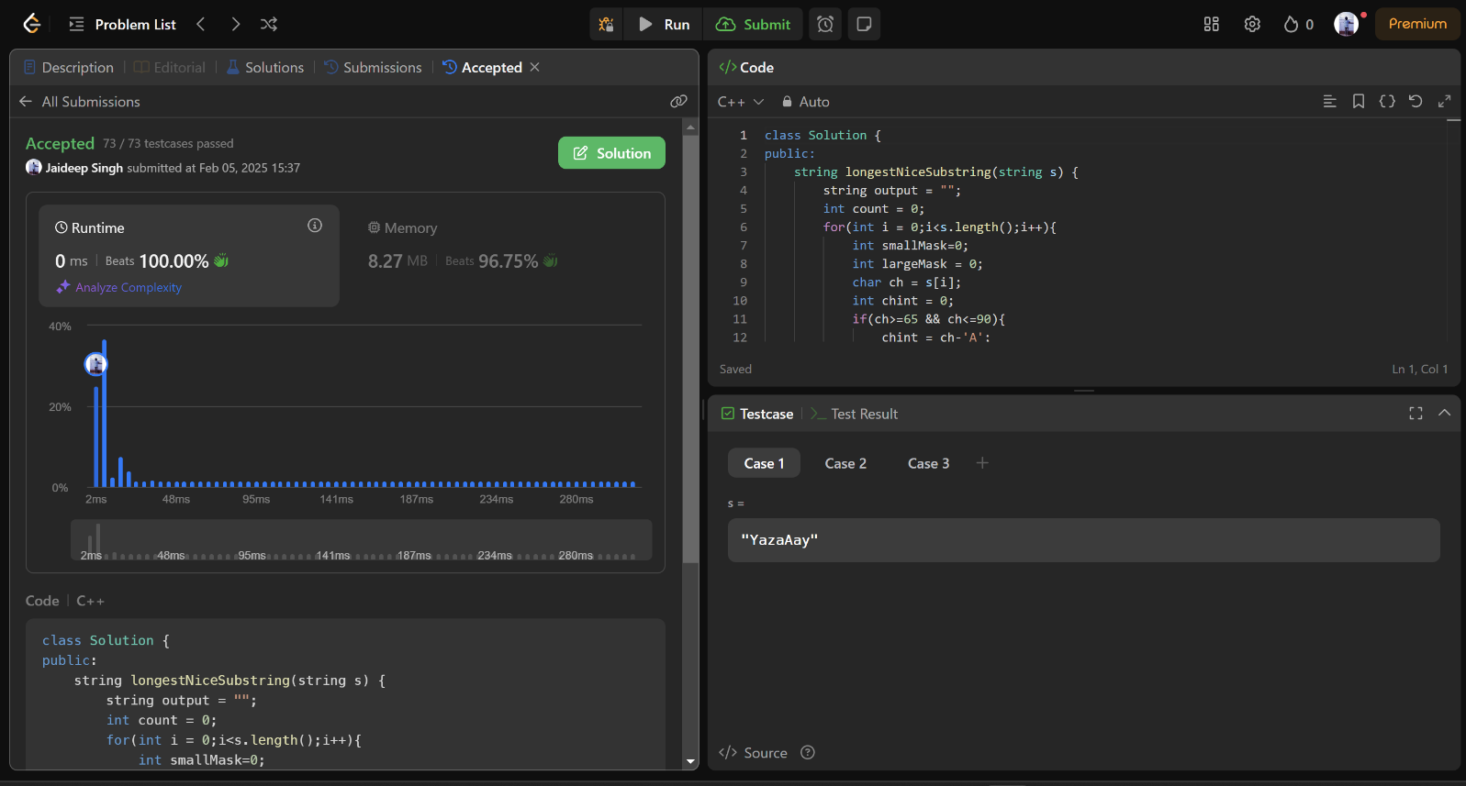

**190.**[**Reverse Bits**](https://leetcode.com/problems/reverse-bits/description/)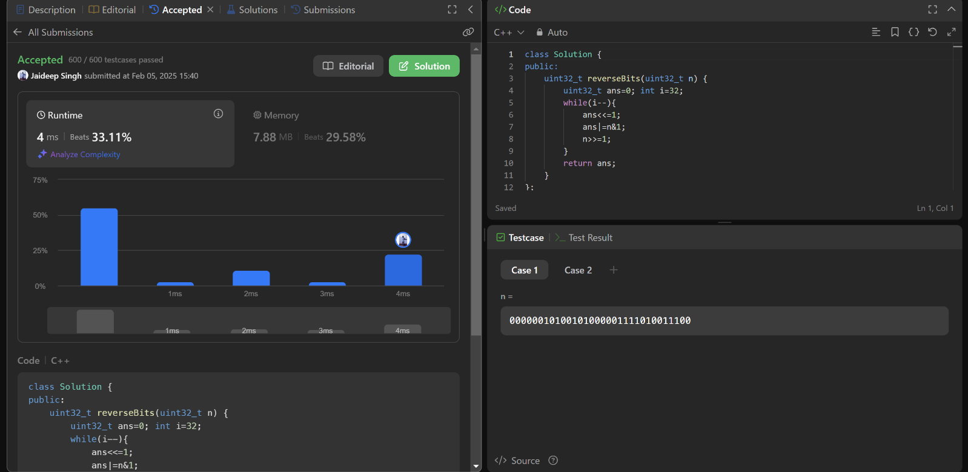

**191.**[**Number of 1 Bits**](https://leetcode.com/problems/number-of-1-bits/description/)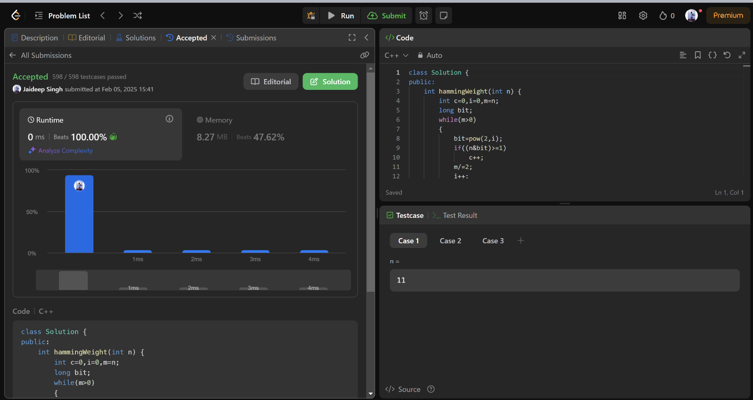

**53.**[**Maximum Subarray**](https://leetcode.com/problems/maximum-subarray/description/)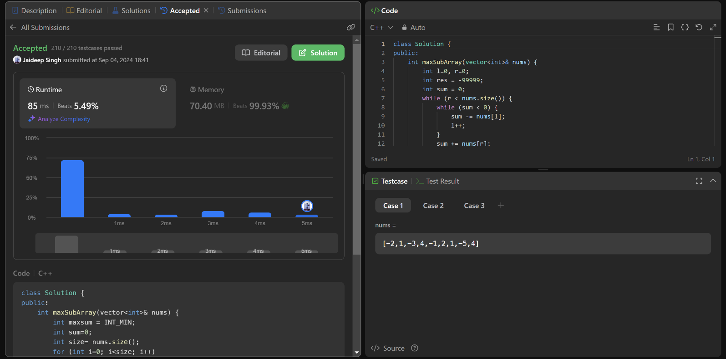

**240.**[**Search a 2D Matrix II**](https://leetcode.com/problems/search-a-2d-matrix-ii/description/)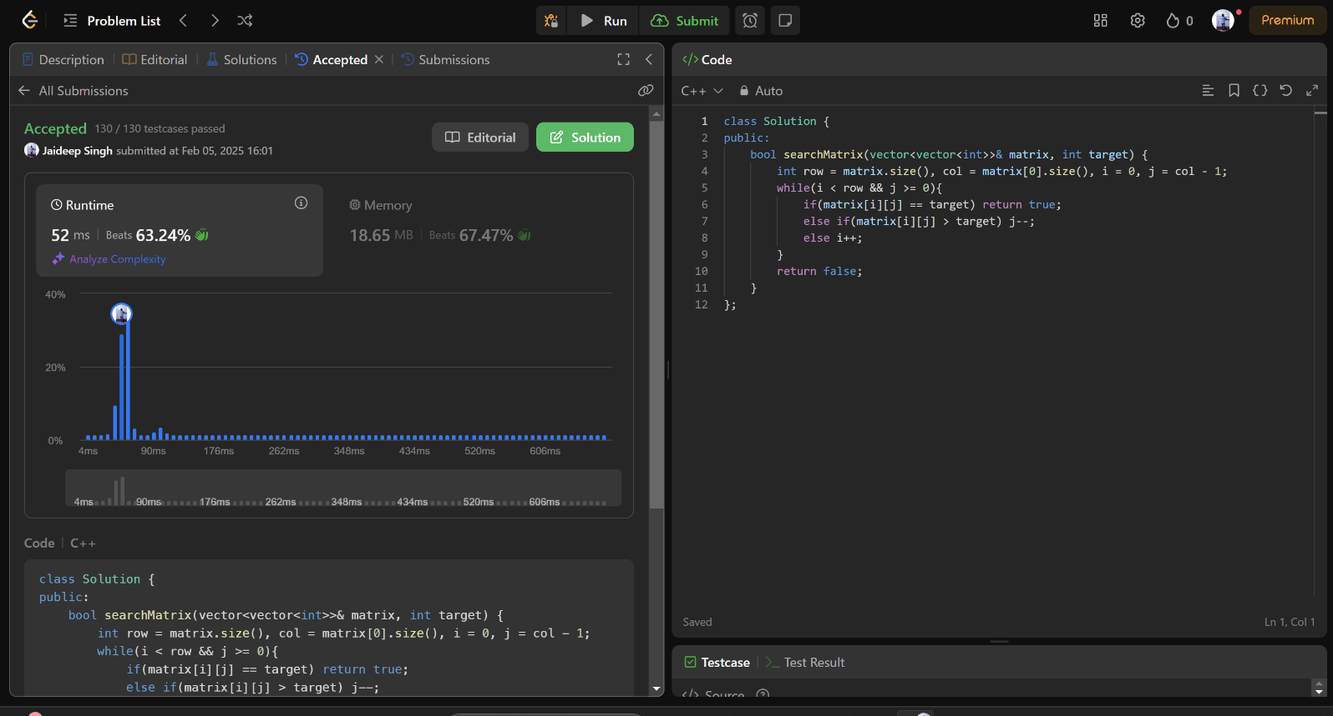

**372.**[**Super Pow**](https://leetcode.com/problems/super-pow/description/)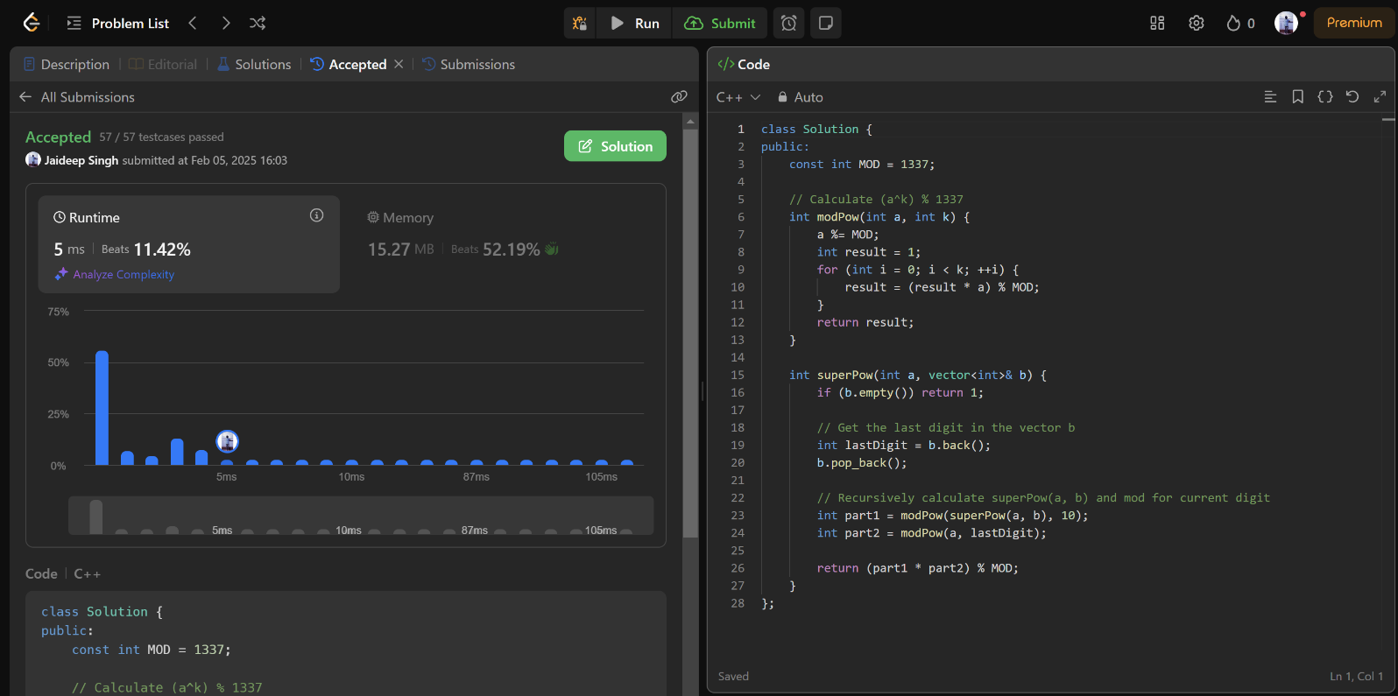

**932.**[**Beautiful Array**](https://leetcode.com/problems/beautiful-array/description/)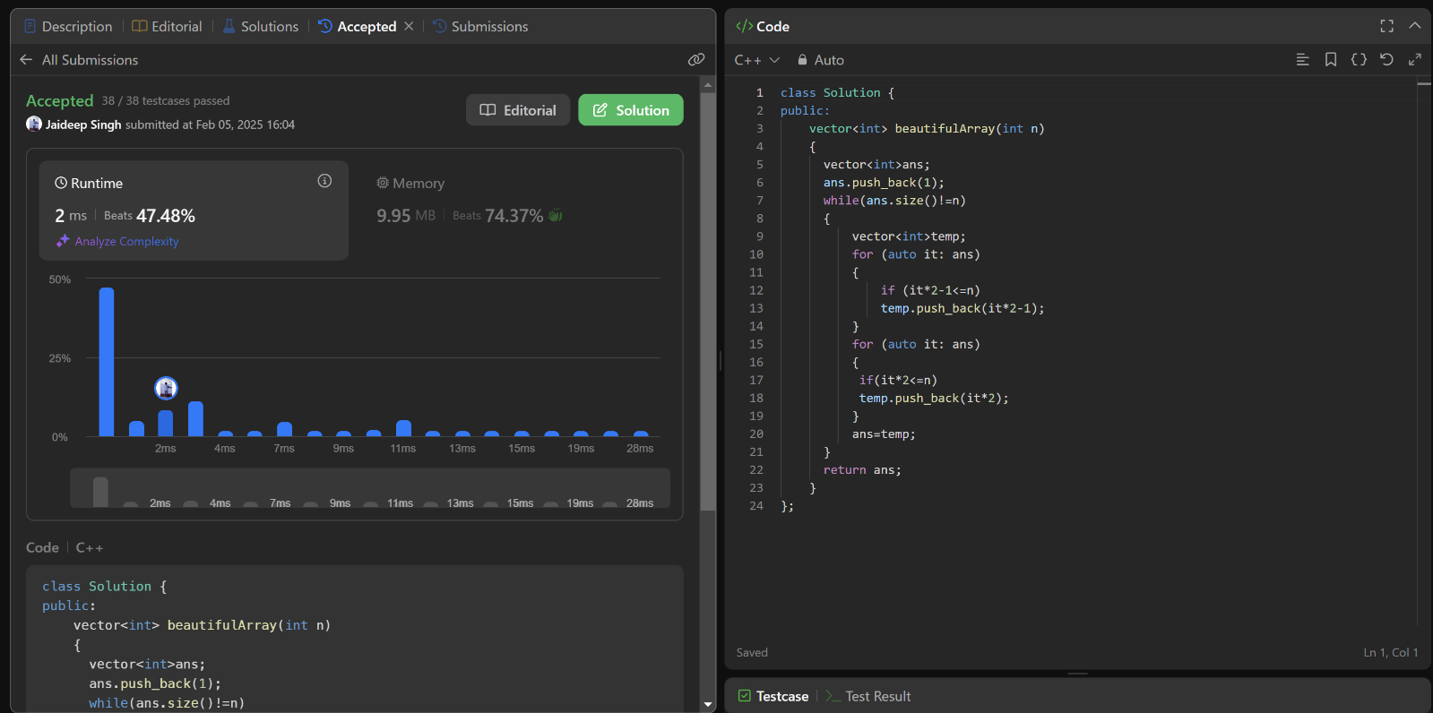

**218.**[**The Skyline Problem**](https://leetcode.com/problems/the-skyline-problem/description/)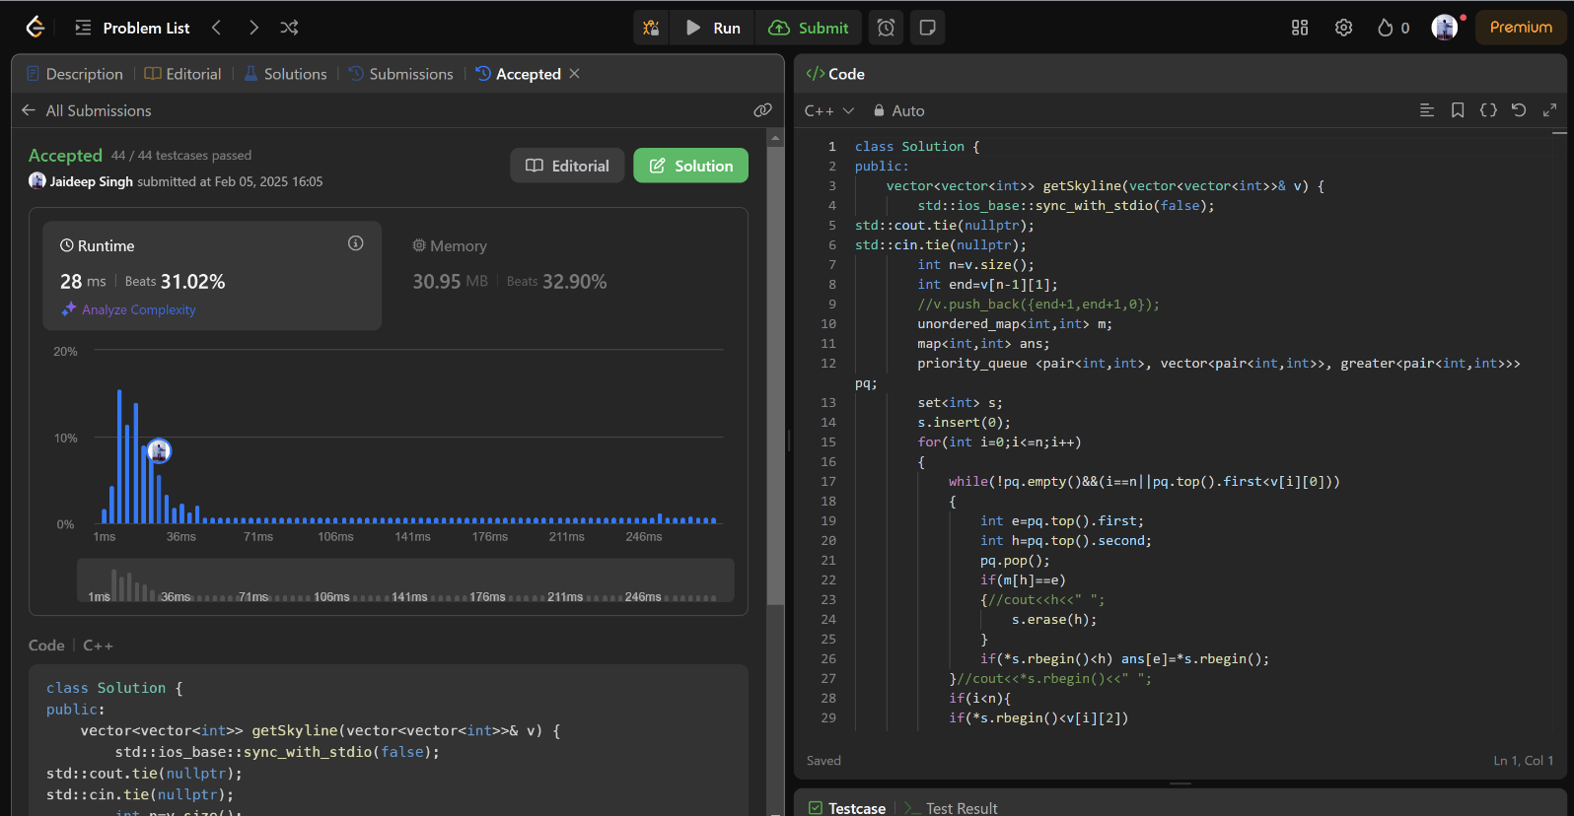

**493.**[**Reverse Pairs**](https://leetcode.com/problems/reverse-pairs/description/)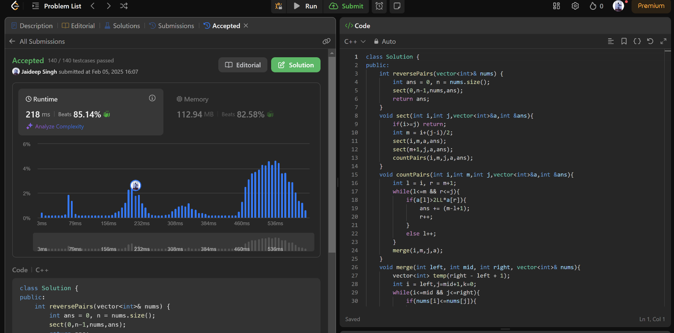

**2407.**[**Longest Increasing Subsequence II**](https://leetcode.com/problems/longest-increasing-subsequence-ii/description/)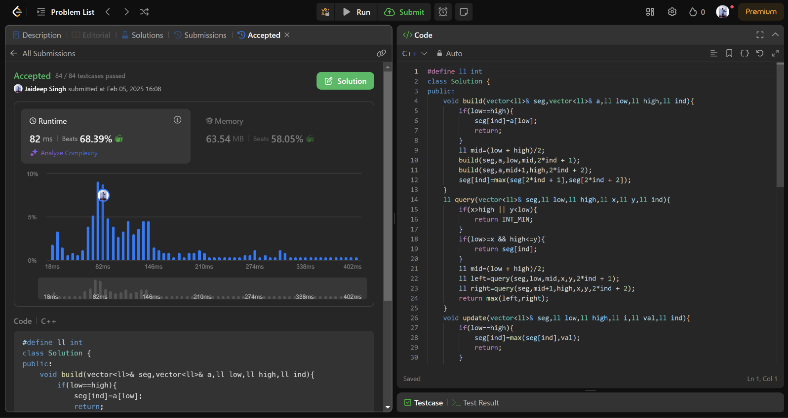

**88.**[**Merge Sorted Array**](https://leetcode.com/problems/merge-sorted-array/description/)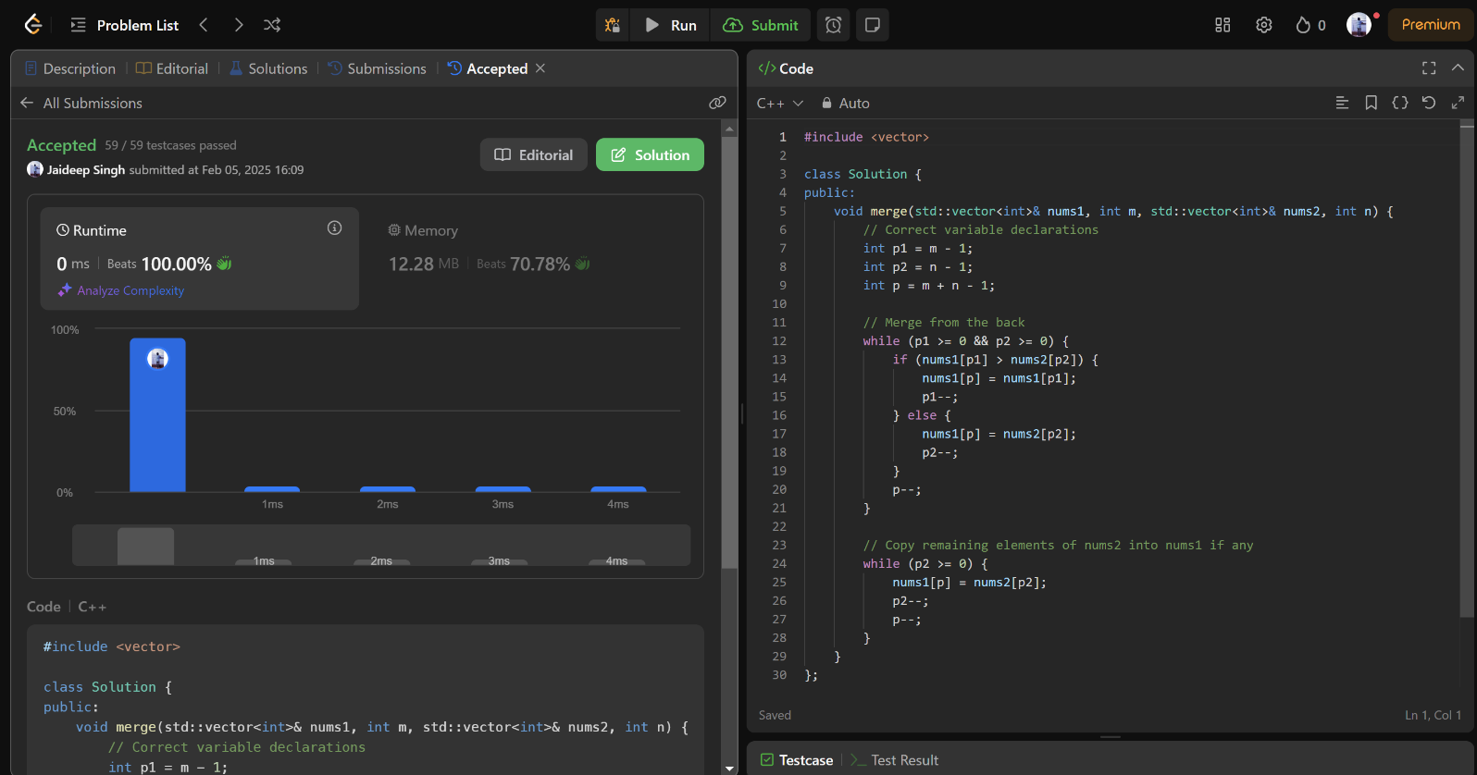

**278.**[**First Bad Version**](https://leetcode.com/problems/first-bad-version/description/)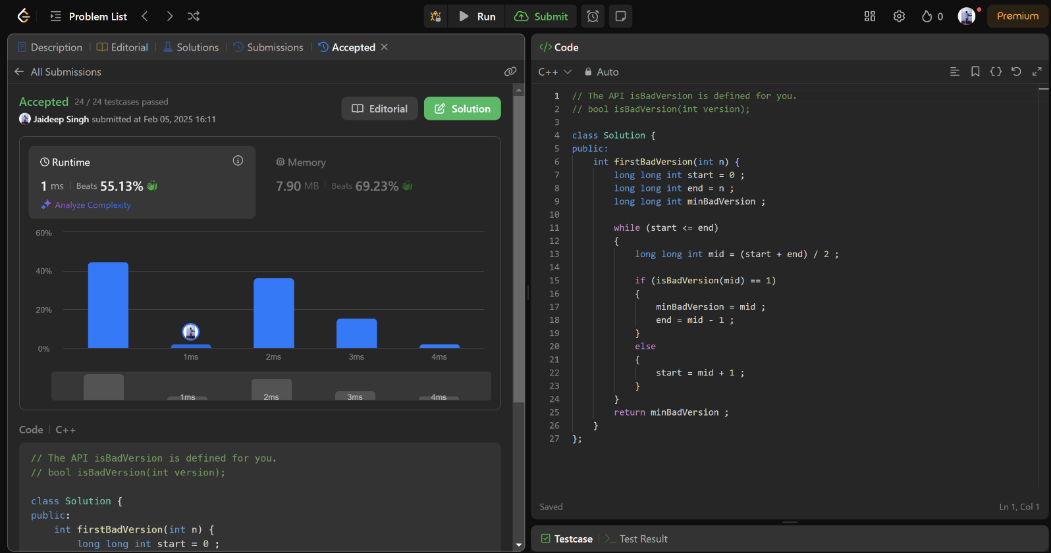

**75.**[**Sort Colors**](https://leetcode.com/problems/sort-colors/description/)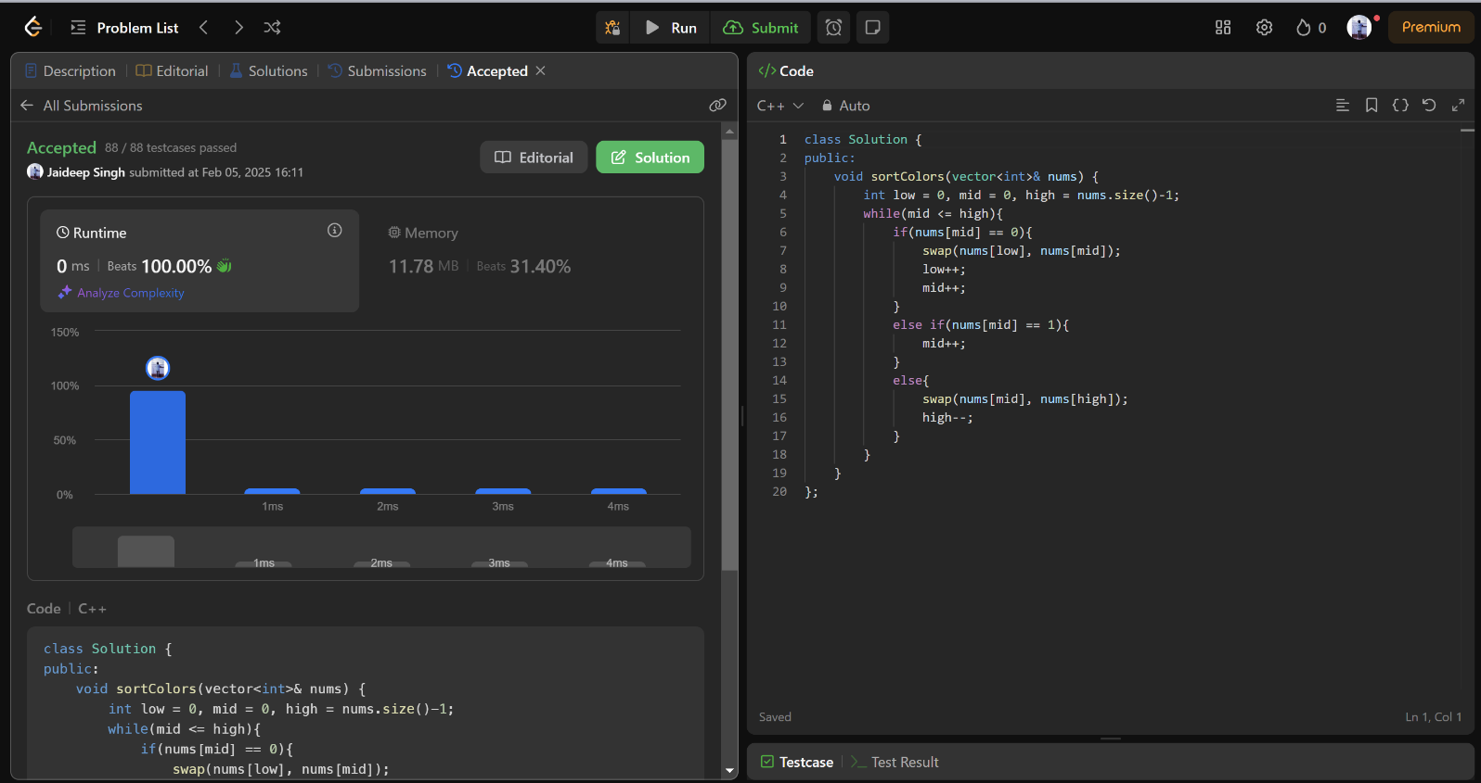

**347.**[**Top K Frequent Elements**](https://leetcode.com/problems/top-k-frequent-elements/description/)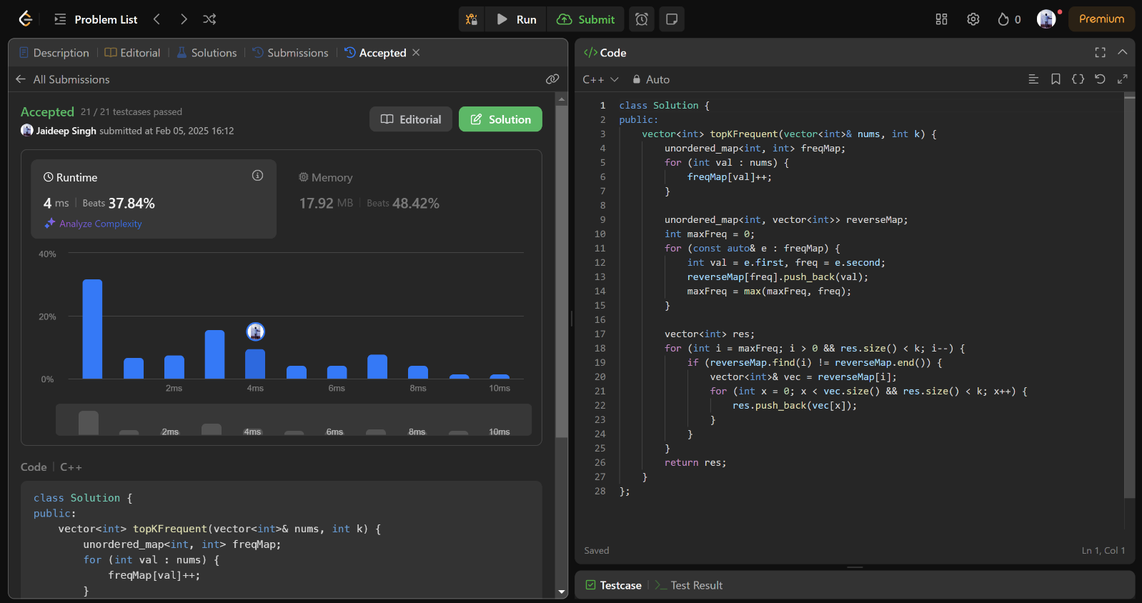

**215.**[**Kth Largest Element in an Array**](https://leetcode.com/problems/kth-largest-element-in-an-array/description/)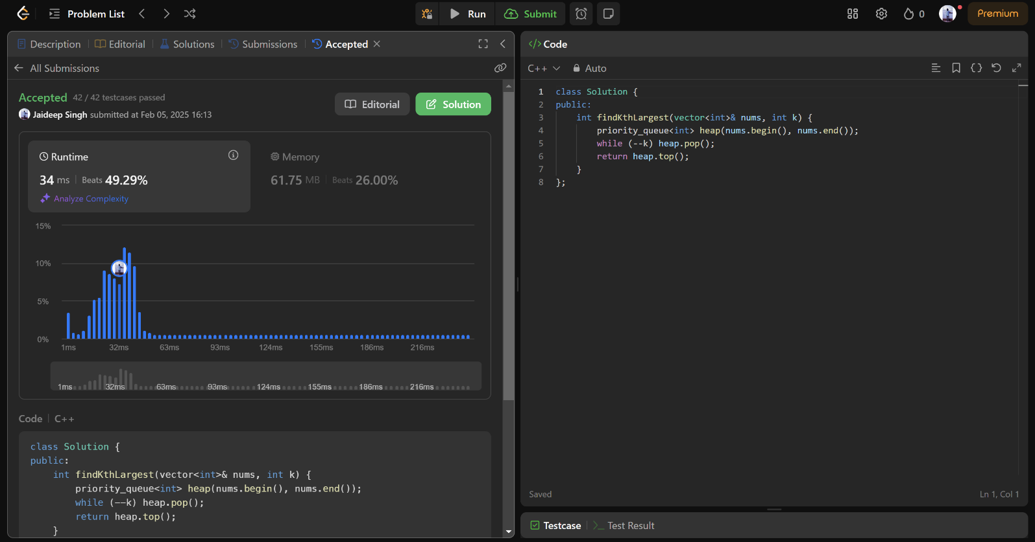

**162.**[**Find Peak Element**](https://leetcode.com/problems/find-peak-element/description/)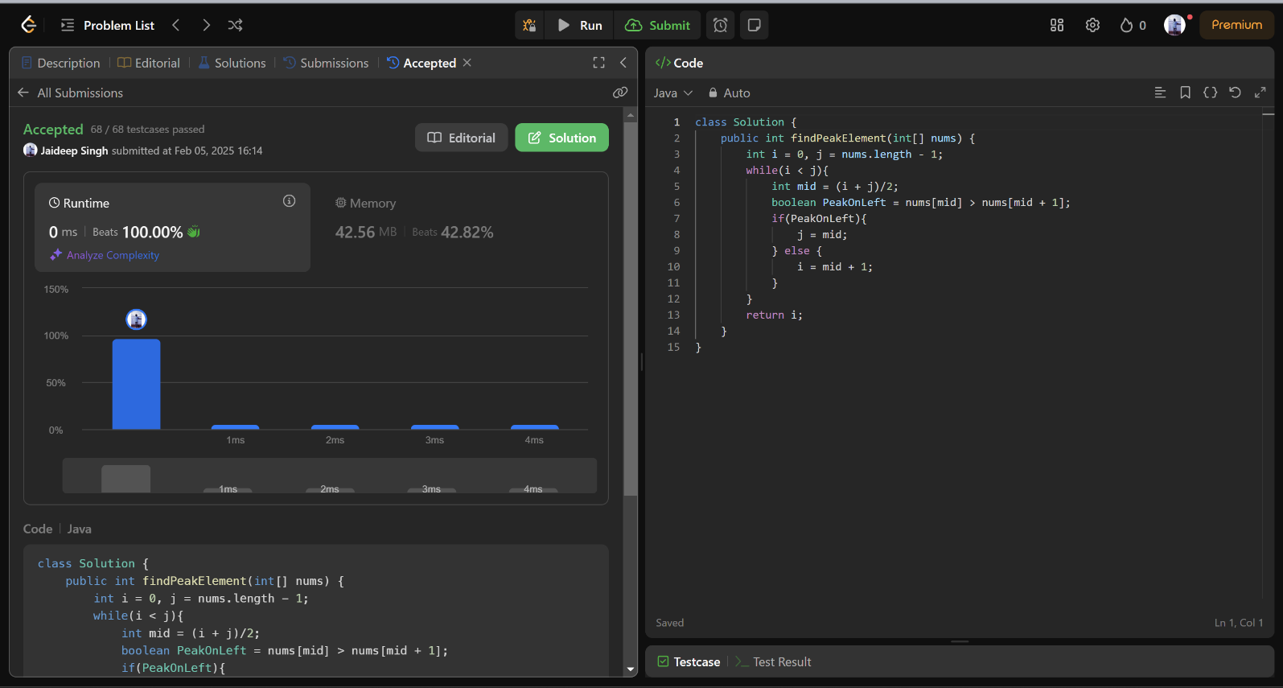

**56.**[**Merge Intervals**](https://leetcode.com/problems/merge-intervals/description/)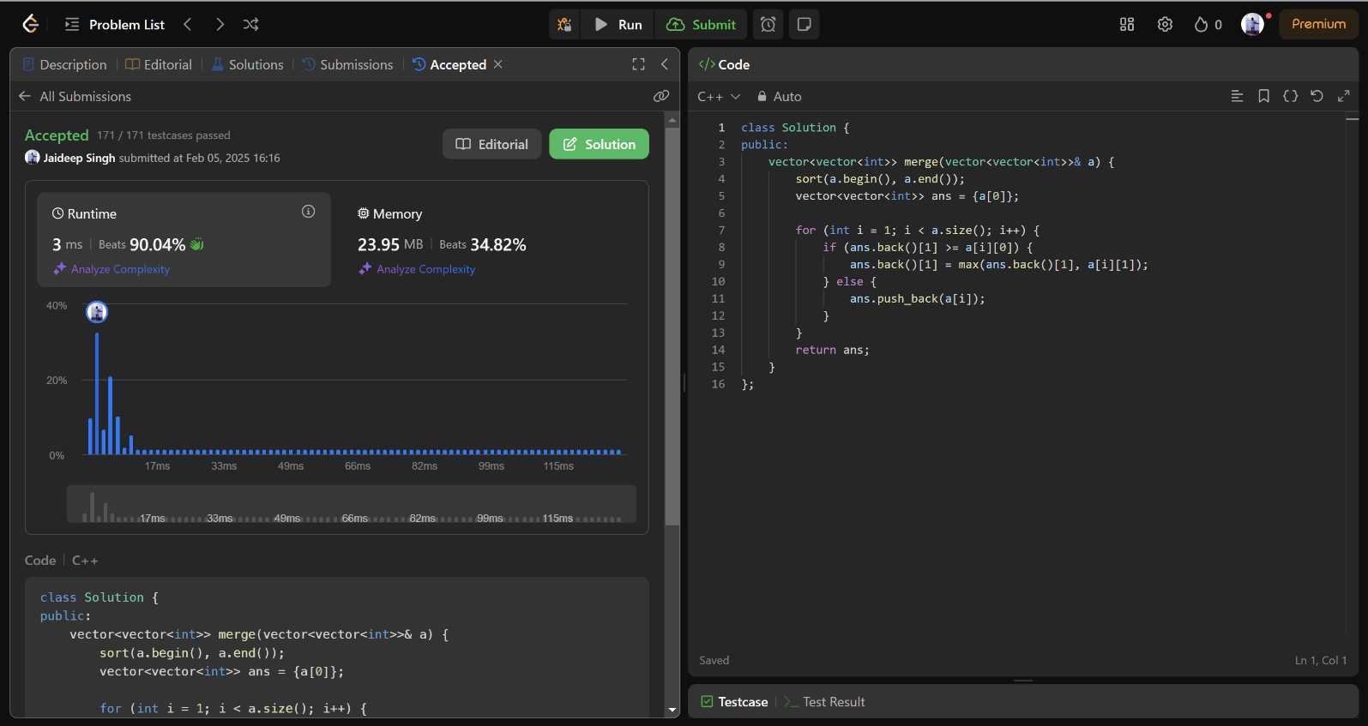

**33.**[**Search in Rotated Sorted Array**](https://leetcode.com/problems/search-in-rotated-sorted-array/description/)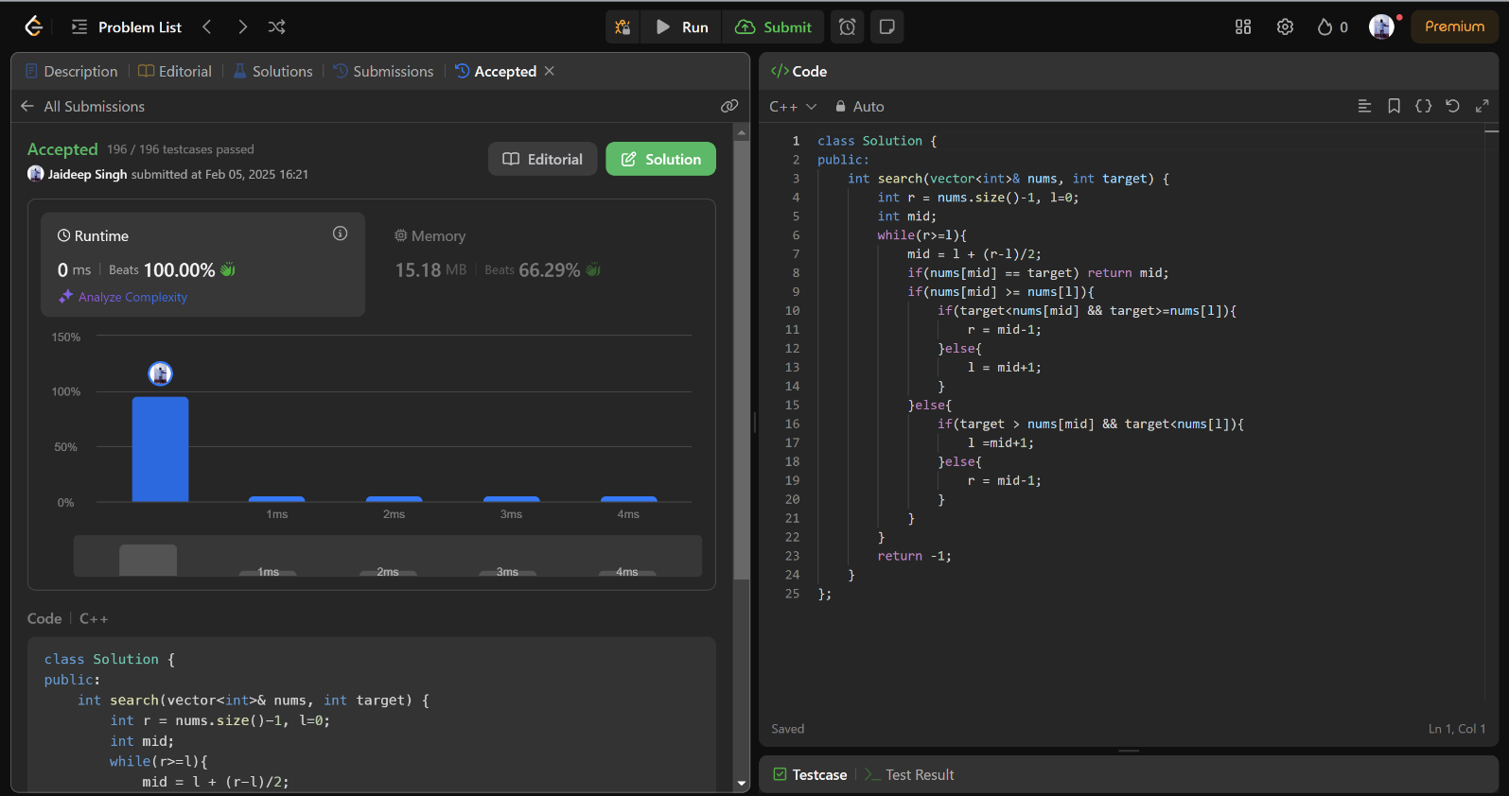

**240.**[**Search a 2D Matrix II**](https://leetcode.com/problems/search-a-2d-matrix-ii/description/)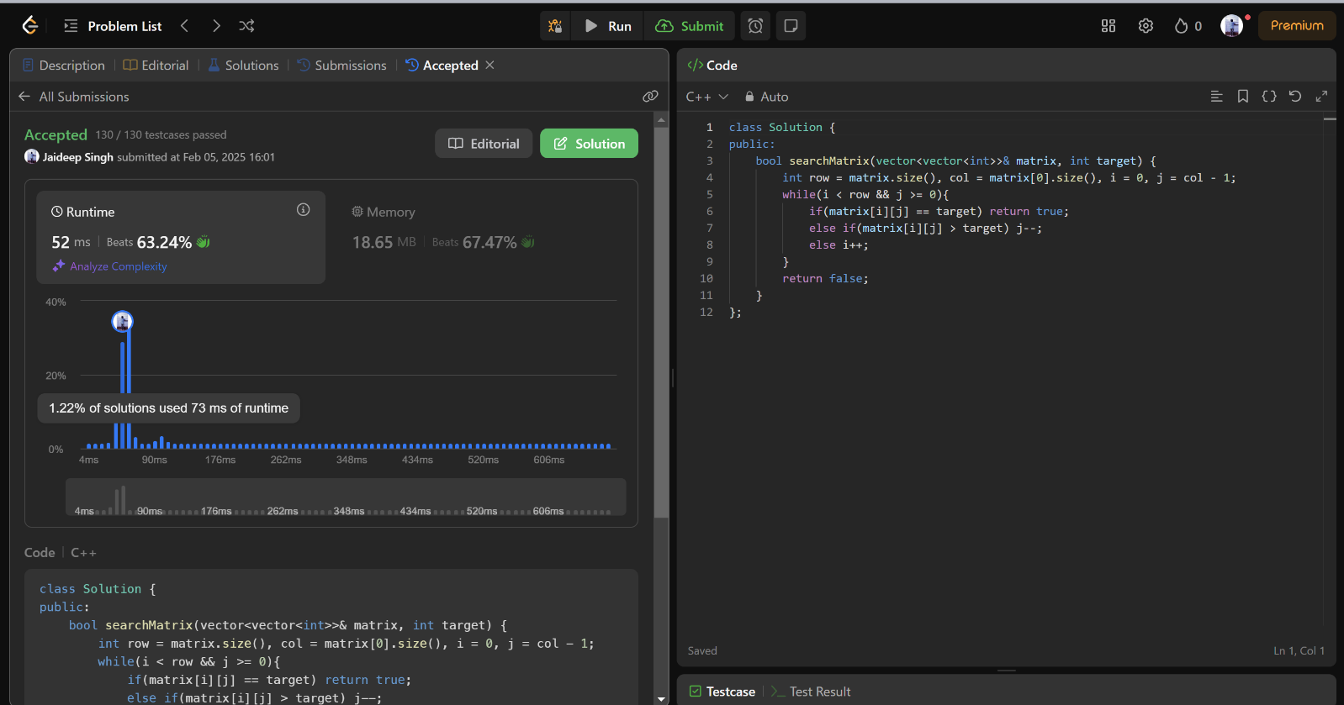

**324.**[**Wiggle Sort II**](https://leetcode.com/problems/wiggle-sort-ii/description/)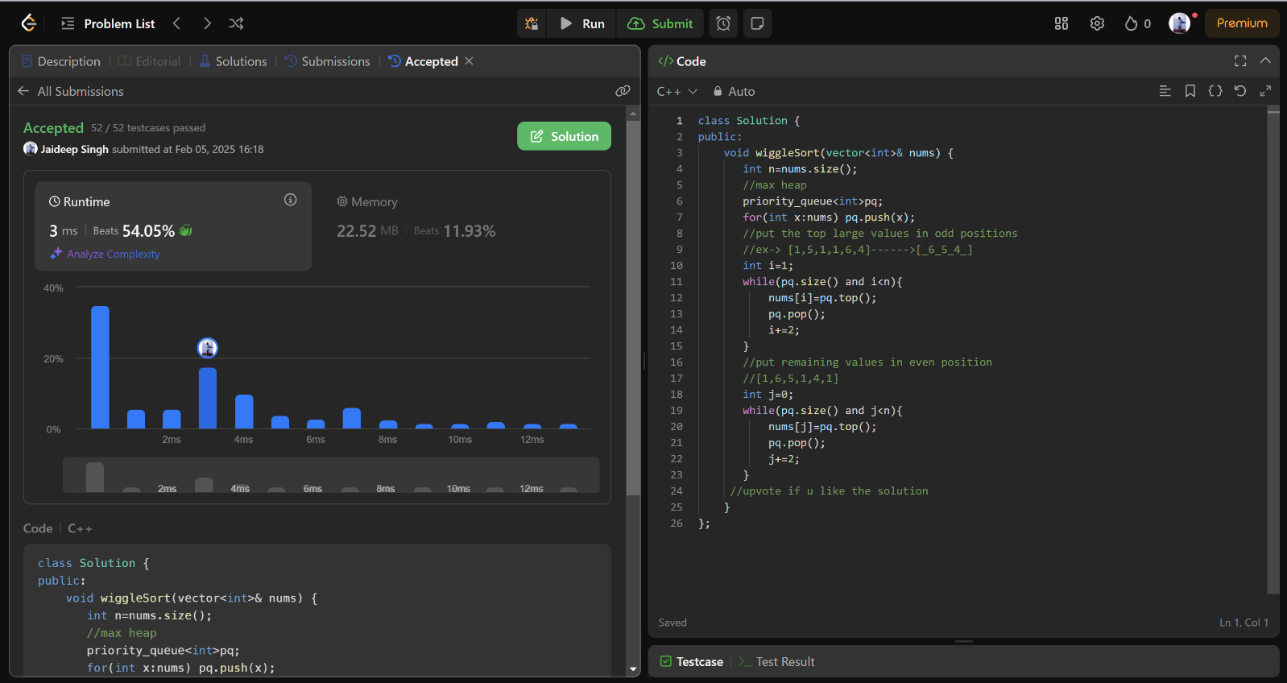

**378.**[**Kth Smallest Element in a Sorted Matrix**](https://leetcode.com/problems/kth-smallest-element-in-a-sorted-matrix/description/)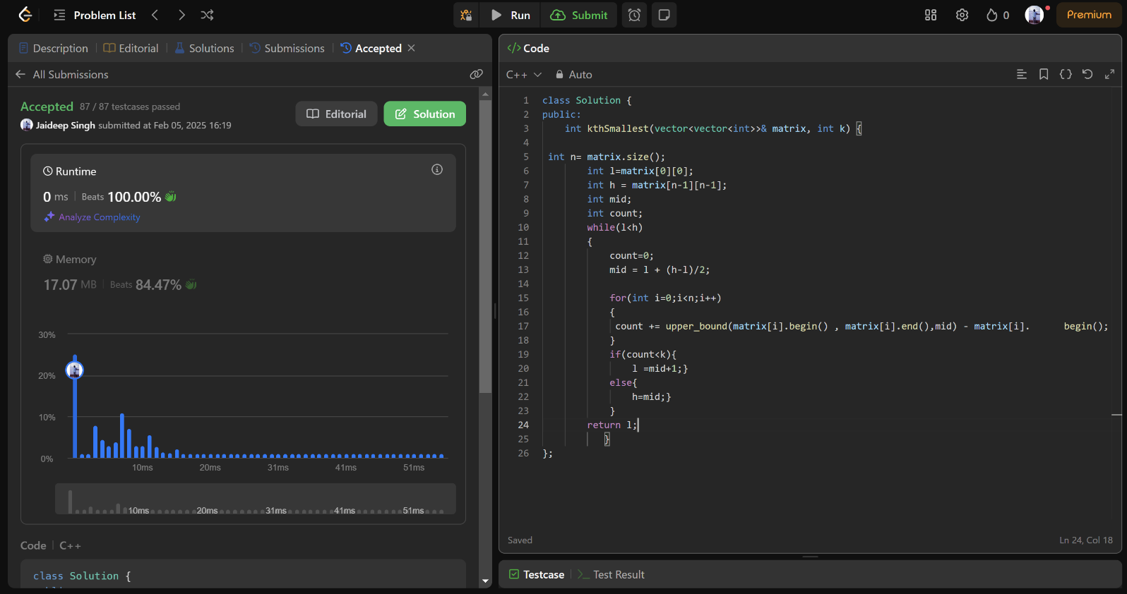

**4.**[**Median of Two Sorted Arrays**](https://leetcode.com/problems/median-of-two-sorted-arrays/description/)

